PRESS RELEASE

FOR IMMEDIATE RELEASE

ROUND BRITAIN ERIB ANNOUNCES HEADLINE PREMIUM SPONSORSHIP WITH GILL
Harry Besley, the 17-year-old Round Britain eRIB Challenge skipper, is delighted to announce that renowned marine clothing brand GILL have signed up to pledge support as a Premium Sponsor. Aligned with their intent to ‘inspire the next generation of adventurers, to push boundaries and challenge the norm’, they were captivated by his sheer determination and forward-thinking plans.
The world-leading marine clothing manufacturers were keen to jump on board and support this enterprising green initiative. “It’s been really interesting to learn about Harry’s challenge and the complexities associated with it,” said Rachel Pratt, Senior Marketing Manager at GILL. “It’s such an important issue that needs attention and we have a huge amount of admiration for what he is doing. We hope this is the start of positive change in the marine industry and will show people that it is possible to still enjoy being out on the water without negatively impacting the marine environment. The path to true sustainability is a long one, but together we can play our part in protecting the environment.”
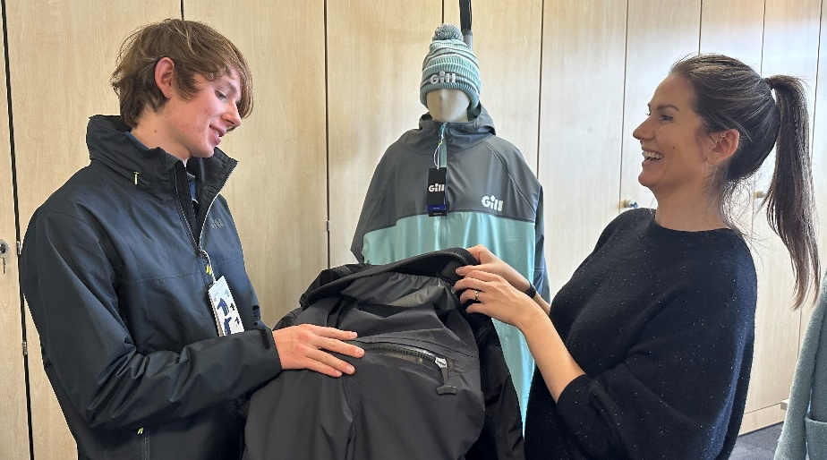
Thrilled to receive this level of commitment from a global marine figurehead in the green sector, Project Manager at Round Britain eRIB, Jaqui Besley commented, “We were keen to work with a brand who have a strong focus on sustainability and GILL have been driving this agenda for years. It is a really good fit, with their unique waterproof XPEL® fabric finish free of harmful PFCs, plus the Eco Pro Rash Vest and Holcombe Crew range, that use polyester fibres from ocean sourced PET plastic bottles.”
In addition, the team has welcomed Vulkan Technologies as a Gold Sponsor. This market leader for technology across the marine, industrial and energy sectors has five production sites, over 50 sales companies and around 1,400 employees worldwide.
“Vulkan is happy to support Harry on his Round Britain voyage and is already working on some interesting projects in the field of electric/hybrid propulsion. This challenge will hopefully promote these projects for us as well as the eRIB challenge itself! said Adrian Birkin, MD, Vulkan UK
A second Gold Sponsor, recently signed up is Bournemouth and Poole College. They will be providing online educational resources that will be available to download from the eRIB Challenge website.
David Massieu-King, Business Development Manager at Bournemouth & Poole College, said: “We’re really pleased to be supporting this exciting adventure. As a college, we pride ourselves in being at the forefront of marine education and working with local and national employers. We hope this inspires both young and old to learn more about the marine industries of the UK, the importance of sustainability and how both can work together to make a difference.”
Harry is aiming to circumnavigate Britain in an electric power boat (RIB) this summer and will be at the South Coast and Green Tech Boat Show 21st – 23rd April at Ocean Village, Southampton. Register now on the website for FREE event tickets and come and meet the team. (https://www.mdlmarinas.co.uk/events/boat-show-tickets/)
Working with British Marine and the RYA, through their joint Green Blue initiative, the team aims to increase public knowledge and deeper understanding of why the development of a sustainable leisure marine sector and related infrastructure is crucial.
Fundraising Promise: This is a non-profit activity, no wages are being paid and all funds will be directed towards achieving our core objectives: raising the profile of the innovators and investors in the sector, building public awareness of products in the market, developing and sharing knowledge and skills, supporting marine charities and ultimately leaving a legacy for the future.

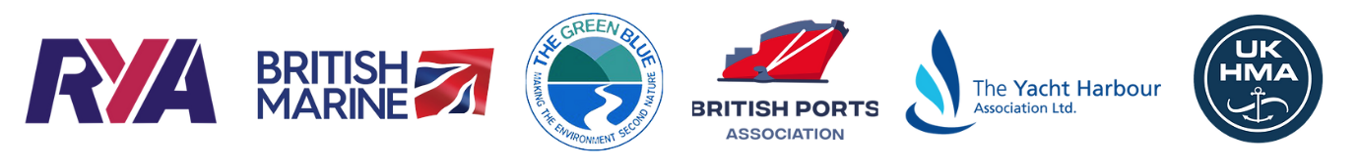

ENDS

Notes to editors:

The Round Britain eRIB Challenge is a not-for-profit environmental project aiming to support leisure and small commercial operators in the marine industry in their transition to a more sustainable future. The challenge involves a 17-year-old RIB skipper attempting to drive an electric boat around the coast of Britain in summer 2023. This will highlight the opportunities for the use of electric propulsion systems in UK coastal waters and is supported by several key industry bodies including RYA, British Marine, British Ports Association, The Yacht Harbour Association, UK Harbour Masters Association, and The Green Blue.

This project will:
- Support the Clean Maritime Plan target that all new vessels being ordered for use in UK waters are designed with zero emission propulsion capability
- Enable more local sailing clubs, marinas, harbour authorities, port operators and private owners to access eBoat charging facilities
- Showcase the potential of eBoats in UK Coastal waters
- Set a baseline for eBoating capabilities in 2023 and set a target for future Challenges to beat

roundbritain-erib.org
Instagram
Facebook

For sponsorship and other enquiries please contact:
Jaqui Besley
Project Manager
jaqui@roundbritain-erib.org
M: +44 7970 173155

For media enquiries please contact:
Amanda Thibaut
PR Manager
Ginger Marine Marketing Agency
amanda@gingeragency.co.uk
M: +44 7796 121717

Ginger Agency
Scobbishcombe Farm, Yealmpton, Devon, PL8 2EW
UK

For all enquiries, please contact us at: hayley@gingeragency.co.uk

If you would like to opt out of future emails, please unsubscribe

