PRESS RELEASE

FOR IMMEDIATE RELEASE

ROUND BRITAIN ERIB ANNOUNCES EDUCATIONAL OUTREACH
Harry Besley, the 17-year-old skipper for the Round Britain eRIB Challenge, is delighted to announce that FREE STEM resources to accompany his epic journey will be available to download from the website. These will broaden engagement and support within schools, colleges, youth groups and home school educators, enabling a greater understanding of some of the more technical elements of the Challenge.
Targeting children in Years 5 and 6, Harry has won the high profile support of award-winning adventurer Jordan Wylie, MBE who is funding the development of the Key Stage 2 resources. Jordan set up EXPEDITION STEM (www.expeditionstem.co.uk) to bring adventure into the classroom, and to inspire young people to gain a greater appreciation of the natural world around them.
"The EXPEDITION STEM Round Britain eRIB resource is designed to inspire KS2 children through the spirit of adventure. It follows Harry as he prepares for his challenge, and provides differentiated, curriculum-linked STEM activities for each stage of his journey."
Jordan Wylie MBE, Founder EXPEDITION STEM
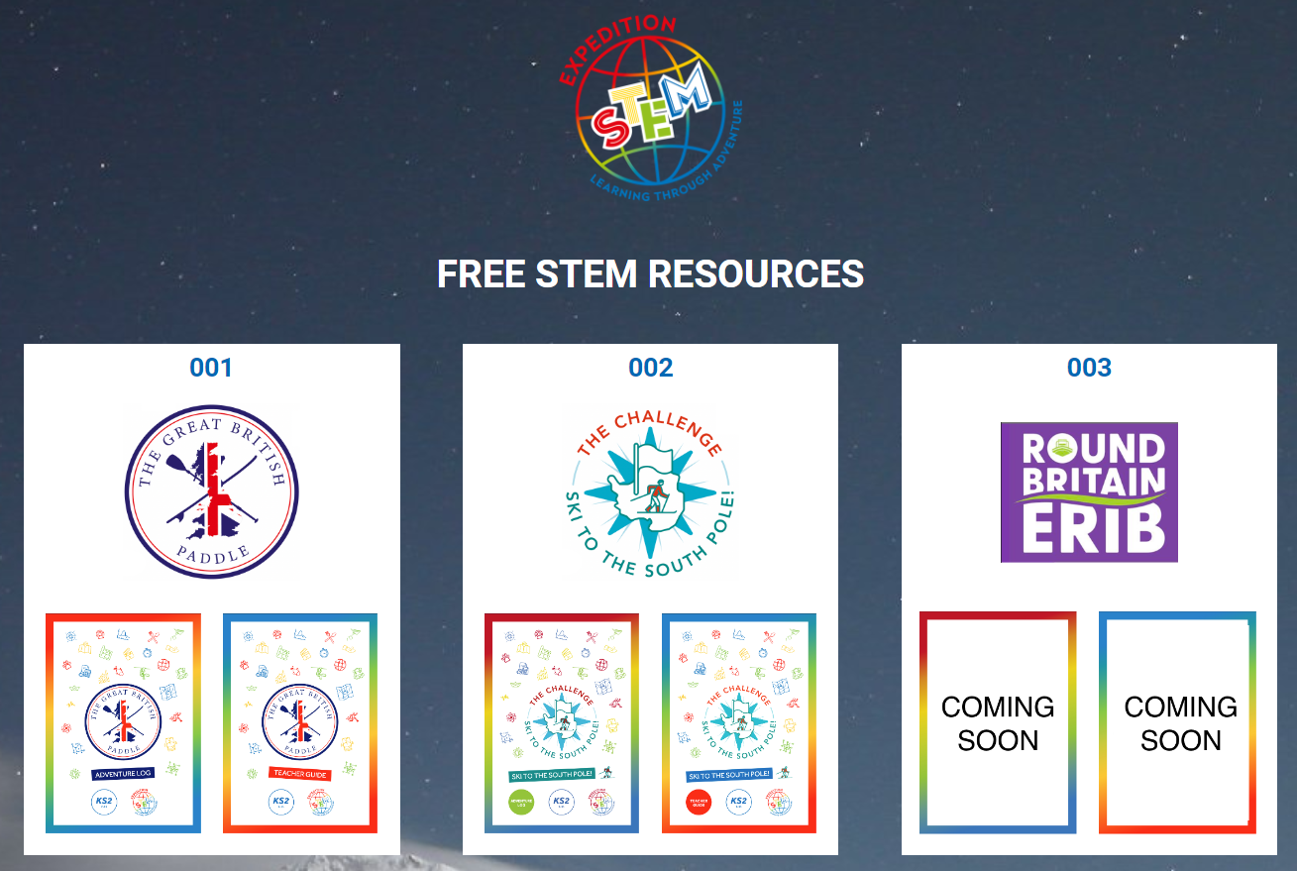
In addition, Harry and the Round Britain eRIB Challenge team are working with Bournemouth & Poole College who specialise in technical education and recognise the urgency of addressing the environmental challenges faced by the marine sector.
By working with the eRIB Challenge, the college hopes to support the journey and the learning around it. Under the guidance of passionate and experienced tutors, Bournemouth & Poole College will create a number of resources that will be specially tailored to relevant subjects such as high voltage battery systems, shore side charging, electric propulsion, types of battery chemistry and health & safety to promote curiosity and knowledge of the industry. The aim is for these resources to give students a stepping-stone into further learning within this industry.
“We are really excited to be a part of the eRIB Challenge and contribute to the future generation of the marine sector” said David Massieu-King, Business Development Manager “By providing educational resources, our aim is to invite students to learn about the innovative solutions that promote sustainability in the marine sector and discover where their future could take them”.
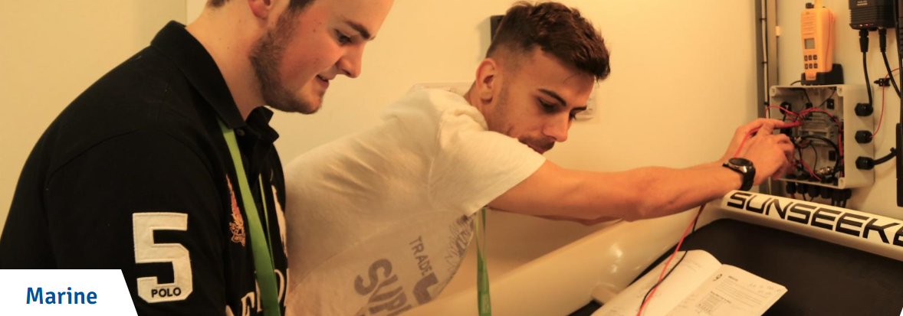
The resources will be available in June to enable discussion in the build up to the Challenge.
Members of the public are also encouraged to enter the Challenge Prize Draw with a chance to win a personal Meet and Greet with the Skipper and a jet boarding experience for two from our Partner at ASAPwatercraft.com.
If you are able to help us with fundraising for the Challenge, do please consider our Commercial Sponsorship Packages and contact Jaqui on admin@roundbritain-erib.org.
Fundraising Promise: This is a non-profit activity. No wages are being paid and all funds will be directed towards achieving our core objectives: raising the profile of the innovators and investors in the sector, building public awareness of products in the market, developing and sharing knowledge and skills, supporting marine charities and ultimately leaving a legacy for the future.

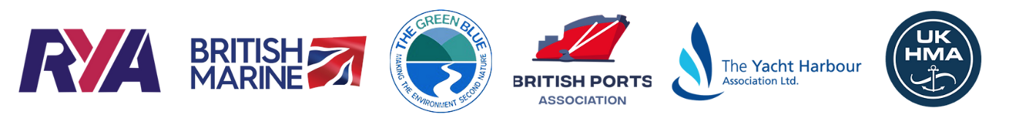

ENDS

Notes to editors:

The Round Britain eRIB Challenge is a not-for-profit environmental project aiming to support leisure and small commercial operators in the marine industry in their transition to a more sustainable future. The challenge involves a 17-year-old RIB skipper attempting to drive an electric boat around the coast of Britain in summer 2023. This will highlight the opportunities for the use of electric propulsion systems in UK coastal waters and is supported by several key industry bodies including RYA, British Marine, British Ports Association, The Yacht Harbour Association, UK Harbour Masters Association, and The Green Blue.

This project will:
- Support the Clean Maritime Plan target that all new vessels being ordered for use in UK waters are designed with zero emission propulsion capability
- Enable more local sailing clubs, marinas, harbour authorities, port operators and private owners to access eBoat charging facilities
- Showcase the potential of eBoats in UK Coastal waters
- Set a baseline for eBoating capabilities in 2023 and set a target for future Challenges to beat

roundbritain-erib.org
Instagram
Facebook

For sponsorship and other enquiries please contact:
Jaqui Besley
Project Manager
jaqui@roundbritain-erib.org
M: +44 7970 173155

For media enquiries please contact:
Amanda Thibaut
PR Manager
Ginger Marine Marketing Agency
amanda@gingeragency.co.uk
M: +44 7796 121717

