PRESS RELEASE

FOR IMMEDIATE RELEASE

NEW FOCUS THIS SUMMER FOR ROUND BRITAIN eRIB CHALLENGE
The Round Britain eRIB Challenge team has today announced a revised focus for this year, as they dedicate their efforts to supporting their partner boat builder through sea trials for the Challenge vessel. While the full event is now postponed until 2024, due to delays in the production schedule, this shift allows the team to gather comprehensive performance data during extensive sea trials. This valuable information will then be integrated into the planning for next year’s Challenge, enabling the Locations and Meet and Greet teams to publicise a more informed schedule to support this exciting event.
“Whilst we are disappointed both for ourselves and for the Locations Teams who have been making preparations to support us, considering the extreme nature of the Challenge and the new technology in play, there was always a delivery risk involved. There are however, definite benefits from this postponement as the boat builder will now have more time to optimise the vessel for use and we can further develop our story around the environmental urgency for driving change into this sector.” Jaqui Besley, Round Britain eRIB, Project Manager
Sponsors and supporters have been quick to pledge their continued support for the project and the first educational resources will be piloted with selected schools this Summer. Further sponsors are still sought for the Challenge event next year, and for more information please contact the Project.
Harry Besley, Skipper said,

“I’m really disappointed not to be touring the UK this summer to demonstrate electric propulsion, but I am definitely looking forward to seeing the Challenge vessel and testing out what it can achieve. The good news is we will be able to share some of our findings from the sea trials with our followers on social media which will no doubt start building even more interest and engagement in this project, ready for next year.”

While the rescheduling of the event is unfortunate, the Round Britain eRIB Challenge team remains optimistic, motivated and resilient, determined to make the most of this bonus extended preparation period. Their dedication to environmental advocacy, coupled with the support of their partners and sponsors, will ensure that the Round Britain eRIB Challenge is a remarkable and impactful event when it sets off, well-prepared and raring to go, in 2024.
Fundraising Promise: This is a non-profit activity. No wages are being paid and all funds will be directed towards achieving our core objectives: raising the profile of the innovators and investors in the sector, building public awareness of products in the market, developing and sharing knowledge and skills, supporting marine charities and ultimately leaving a legacy for the future.
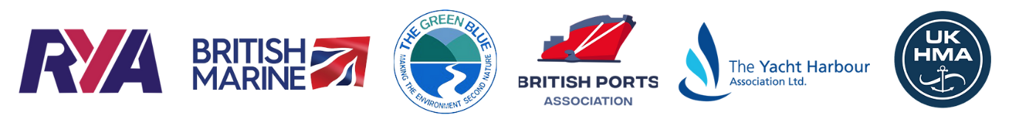

ENDS

Notes to editors:

The Round Britain eRIB Challenge is a not-for-profit environmental project aiming to support leisure and small commercial operators in the marine industry in their transition to a more sustainable future. The challenge involves a 17-year-old RIB skipper attempting to drive an electric boat around the coast of Britain. This will highlight the opportunities for the use of electric propulsion systems in UK coastal waters and is supported by several key industry bodies including RYA, British Marine, British Ports Association, The Yacht Harbour Association, UK Harbour Masters Association, and The Green Blue.

This project will:
- Support the Clean Maritime Plan target that all new vessels being ordered for use in UK waters are designed with zero emission propulsion capability
- Enable more local sailing clubs, marinas, harbour authorities, port operators and private owners to access eBoat charging facilities
- Showcase the potential of eBoats in UK Coastal waters
- Set a baseline for eBoating capabilities and set a target for future Challenges to beat

roundbritain-erib.org
Instagram
Facebook

For sponsorship and other enquiries please contact:
Jaqui Besley
Project Manager
jaqui@roundbritain-erib.org
M: +44 7970 173155

For media enquiries please contact:
Amanda Thibaut
PR Manager
Ginger Marine Marketing Agency
amanda@gingeragency.co.uk
M: +44 7796 121717

