View in Browser

PRESS RELEASE

FOR IMMEDIATE RELEASE

Harry Besley, skipper for the Round Britain eRIB Challenge, has today actively launched his fundraising campaign. With determination that belies his young age, 17-year-old Harry is looking to secure financial support from sponsors over the coming weeks. This backing will help cover the long list of upfront costs involved in his circumnavigation of Britain in an electric power boat (eRIB) during the summer.

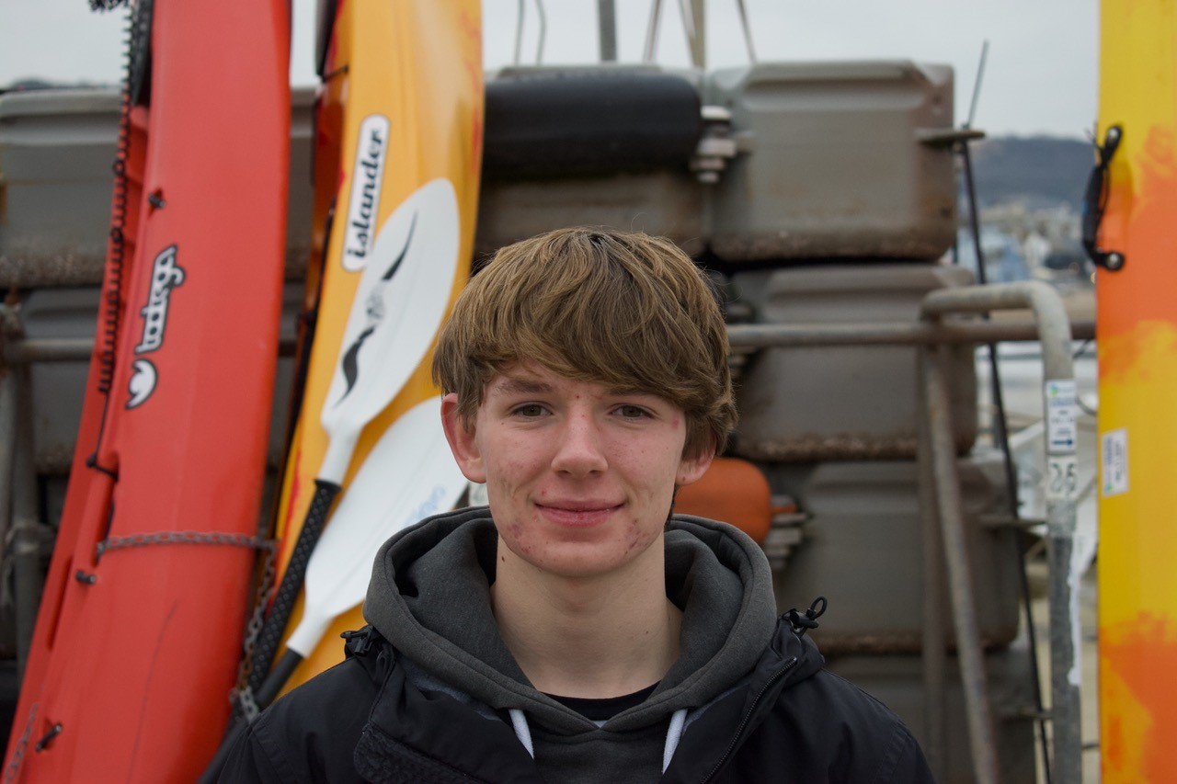

(Additional Image: credit Gav Roberts)

The challenge team has established varying levels of sponsorship for supporters to champion this unique world record challenge and commercial sponsors can benefit from significant media exposure. In addition, the team are offering custom deals to tailor sponsorship publicity to the size of the donation. All direct fundraising that the team establishes now will secure the essential kit and equipment to carry out the challenge, and the majority of this will be sold afterwards in a ‘Kit Auction’ later this year.

As an environmental challenge, showcasing market-leading zero emission technology, the voyage is now starting to gain momentum. Harry and the team will be hosted by MDL Marinas at the South Coast and Green Tech Boat Show 21-23 April at Ocean Village in Southampton, which provides a great opportunity to meet and chat to them first-hand.

Working with British Marine and the RYA, through their joint Green Blue initiative, the team aims to enhance public knowledge and understanding of why the development of a sustainable leisure marine sector and related infrastructure is crucial.

The main goals of this project are to:

- Support the Clean Maritime Plan target for all new vessels ordered for use in UK waters to be designed with zero emission propulsion capability.
- Enable more local sailing clubs, marinas, harbour authorities, port operators and private owners to access eBoat charging facilities.
- Showcase the potential for using eBoats in UK coastal waters.
- Set a baseline for eBoating capabilities in 2023 and establish a target for future challenges to beat.

Further outlining his resolve to raise funds for this exciting challenge, Harry stated, “We now have the plans and logistics in place, all we need is funding. These projects are unfortunately not cheap and vital items need to be purchased or sadly the challenge cannot continue. For anyone interested in sponsorship, please get in touch with Jaqui our project manager. Full details can be found on our website”.

In addition to the current sponsorship initiative, they are also campaigning to raise donations for marine charities and the main beneficiaries will be announced once agreed with key sponsors. Donations of any amount are being welcomed through the website, with an exclusive chance to enter the Challenge Prize Draw or the amazing opportunity for a name or short message placed on the boat console. A couple of creative standouts already signed up for dedication during the electric circumnavigation are “Derek loves Kirstie!” and "Charge me up! from NYC”.

Fundraising Promise: This is a non-profit activity, no wages are being paid and all funds will be directed towards achieving our core objectives: raising the profile of the innovators and investors in the sector, building public awareness of products in the market, developing and sharing knowledge and skills, supporting marine charities and ultimately leaving a legacy for the future.

ENDS

Notes to editors:

The Round Britain eRIB Challenge is a not-for-profit environmental project aiming to support leisure and small commercial operators in the marine industry in their transition to a more sustainable future. The challenge involves a 17-year-old RIB skipper attempting to drive an electric boat around the coast of Britain in summer 2023. This will highlight the opportunities for the use of electric propulsion systems in UK coastal waters and is supported by several key industry bodies including RYA, British Marine, British Ports Association, The Yacht Harbour Association, UK Harbour Masters Association, and The Green Blue.
roundbritain-erib.org
Instagram
Facebook

For sponsorship and other enquiries please contact:
Jaqui Besley
Project Manager
jaqui@roundbritain-erib.org
M: +44 7970 173155

For media enquiries please contact:
Amanda Thibaut
PR Manager
Ginger Marine Marketing Agency
amanda@gingeragency.co.uk
M: +44 7796 121717

Ginger Agency
Scobbishcombe Farm, Yealmpton, Devon, PL8 2EW
UK

For all enquiries, please contact us at: hayley@gingeragency.co.uk

If you would like to opt out of future emails, please unsubscribe

